OFFER

golden-brown silvery-grey 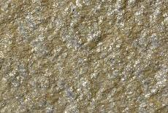 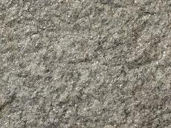

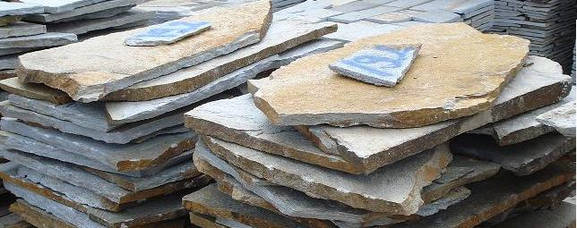
Plates for cutting and flooring - /natural, non shaped/:

№ | Pc./ m²: | Thickness:
1 | to 8 pc. | 1.5 - 4.5 cm
2 | to 4 pc. | 2.0 - 4.0 cm
3 | 12 pc. | 2.0 - 4.0 cm

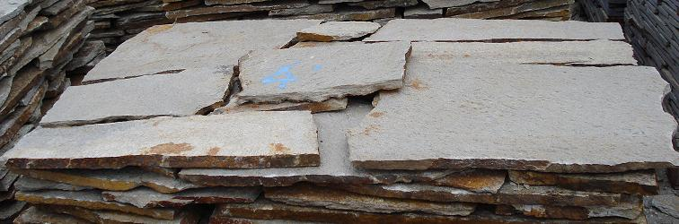
Polygonal plates - /natural, non processed - with different forms/: used for revetment and flooring over a concrete base.
№ | Pc. / m²: | Thickness:
1 | 4 - 15 pc. | 1.5 - 2.5 cm
2 | 8 - 12 pc. | 1.5 - 2.5 cm
3 | 6 - 9 pc. | 1.5 - 2.5 cm

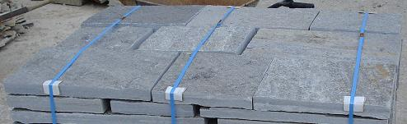
Processed plates - /cut/: used for flooring.

№ | Width: | Length: | Thickness:
1 | 8 cm | free | 2.5 - 4.5 cm
2 | 10 cm | free | 2.5 - 4.5 cm
3 | 15 cm | free | 2.5 - 4.5 cm
4 | 20 cm | free | 2.5 - 4.5 cm
5 | 25 cm | free | 2.5 - 4.5 cm
6 | 30 cm | free | 2.5 - 4.5 cm

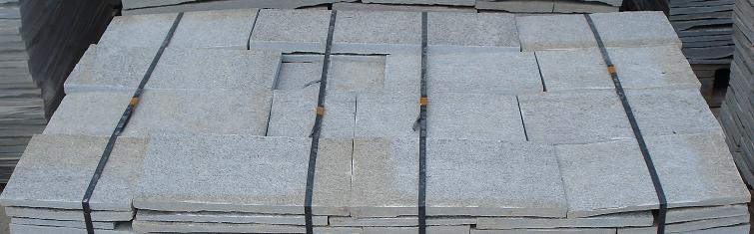
Processed plates - /cut/:
used for revetment and flooring over a concrete base.

№ | Width: | Length: | Thickness:
1 | 8 cm | free | 1.5 - 2.5 cm
2 | 10 cm | free | 1.5 - 2.5 cm
3 | 15 cm | free | 1.5 - 2.5 cm
4 | 20 cm | free | 1.5 - 2.5 cm
5 | 25 cm | free | 1.5 - 2.5 cm
6 | 30 cm | free | 1.5 - 2.5 cm

* Note: That are the basic sizes, with which we work, but we could realize and individual sizes, given by the client.

 | Cutouts - /pieces from cuted plates, suitable for revetment/: |  | 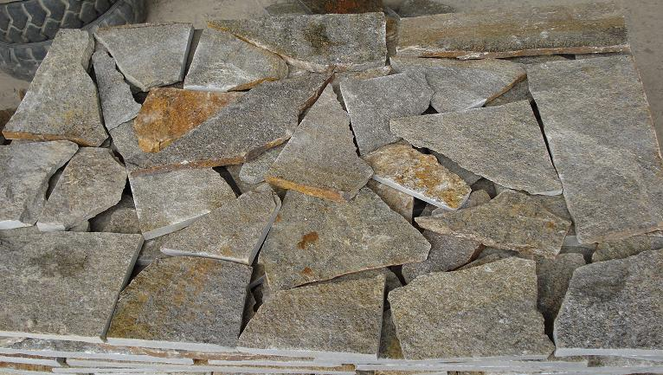
  Pc./ m²: | 5 - 20 pc.
  Thickness: | 1 - 1.5 cm
 | Stones for glitz masonry - /bones/:  thinly cutouts, suitable for decorative masonry. They create illusion for masonry. |  | 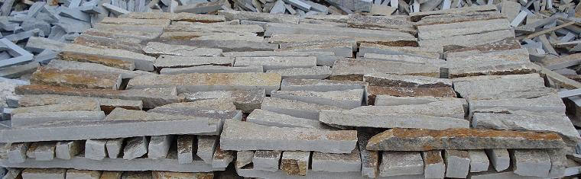
  Width: | 3 - 5 cm
  Length: | 15 - 40 cm
  Thickness: | 3 - 4 cm
 | Building stones - /decorative and complite stone masonry/: |  | 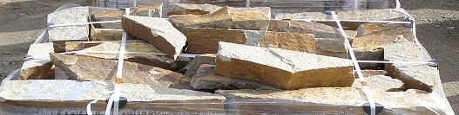
  Height: | 10 - 20 cm
  Length: | 20 - 60 cm
  Thickness: | 10 - 20 cm
 | Paving-stones: |  | 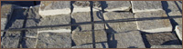

№ | Pc./ m²: | Thickness:
1 | 10 x 10 cm | 1.5 - 2.5 cm
2 | 12 x 12 cm | 1.5 - 2.5 cm
3 | 15 x 15 cm | 1.5 - 2.5 cm
4 | 10 x 10 cm | 2.5 - 4.0 cm
5 | 12 x 12 cm | 2.5 - 4.0 cm
6 | 15 x 15 cm | 2.5 - 4.0 cm

